Row(): pyspark.sql.row which is represented as a record/row in DataFrame, one can create a Row object by using named arguments or create a custom Row like class.

Example:

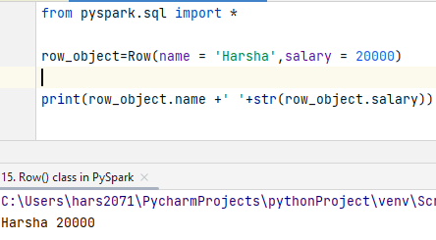

**Creating a DataFrame**

from pyspark.sql import *  
  
*# Example 1*row1 = Row(name = 'Harsha',salary = 20000)  
  
print(row1.name +' '+str(row1.salary)) *# Output: Harsha 20000  
  
# Example 2*row2 = Row('Harshavardhan',29)  
  
print(row2[0] + ' ' + str(row2[1])) *# Output: Harshavardhan 29  
  
# Example 3 - Combining two rows into a DataFrame*spark = SparkSession.builder.appName('Row_Class').getOrCreate()  
  
row3 = Row(name = 'Harsha', age = 29)  
row4 = Row(name = 'Mokshit', age = 29)  
data = [row3,row4]  
  
df = spark.createDataFrame(data)  
  
df.show()

**Output:**

Harsha 20000

Harshavardhan 29

+-------+---+

| name|age|

+-------+---+

| Harsha| 29|

|Mokshit| 29|

+-------+---+

**Create a Row like class**

from pyspark.sql import *  
  
*# Example 1*person = Row('name','salary')  
  
person1 = person('Harsha',20000)  
person2 = person('Mokshit',25000)  
  
print(person1.name +' salary is '+str(person1.salary))  
print(person2.name +' salary is '+str(person2.salary))  
  
*# Example 2 - Create a DataFrame to above Rows*spark = SparkSession.builder.appName('Example2').getOrCreate()  
  
data = [person1,person2]  
  
df = spark.createDataFrame(data)  
  
df.show()

**Output:**

Harsha salary is 20000

Mokshit salary is 25000

+-------+------+

| name|salary|

+-------+------+

| Harsha| 20000|

|Mokshit| 25000|

+-------+------+

**Create nested Struct Type using Row()**

*# Create nested struct type using Row()*from pyspark.sql import *  
  
spark = SparkSession.builder.appName('example2').getOrCreate()  
  
data = [Row(name = 'Harsha', prop = Row(age=29, gender='M')),  
 Row(name = 'Mokshit', prop = Row(age=28, gender='M'))  
 ]  
  
df = spark.createDataFrame(data)  
  
df.show()

**Output:**

+-------+-------+

| name| prop|

+-------+-------+

| Harsha|{29, M}|

|Mokshit|{28, M}|

+-------+-------+